Loan Origination
- Add additional variables to scale.gnm_loan (see spreadsheet) in the same folder
- Do not fill missing values for any variables (for now) that have more than 30% of the data missing. In scale.gnm_loanOrig these are:
  - dti
  - tpoType
  - firstTimeHomeBuyerFlag
  - Add any others
- Fill missing values for the following variables in scale.gnm_loanOrig:
  - origFICO
  - origLTV
  - loanPurposeType
- (Imputation Strategy) Fill origFICO and origLTV as follows:
  - Map loan into loanType (all available)
  - Map loan into origDate (all available)
  - For this loanType and origDate, create a grid with the following dimensions:
    - origNoteRate by 12.5bps (all available) - range from 50 to 1500 bps
    - origLoanSize by $25k (all available) - range from 1K to 220K
    - origLTV by 1% - range from 10 to 125%
    - origFICO by 20 points - range from 300 to 850
  - (Binning approach) Fill in missing values for origLTV and origFICO by placing loan into appropriate bucket (if no such bucket exists then go to Step e below) and taking the weighted-average (by loan balance) for the bucket that corresponds to the missing dimension. Use that weighted-average to fill in the missing value.
  - (Nearest-neighbor approach) If a loan doesn't fit into one of the buckets in the original bucketing scheme, then we map the loan to the closest bucket as calculated by the Gower distance function described in the write-up. For the missing FICO calculation, within the same loanType, in addition to origNoteRate, origLoanSize, and origLTV, we would also take the originationDate into account when calculating distances. This has the benefit of (1) not forcing us into making an series of increasingly ad-hoc buckets so that we can calculate the FICO and (2) also generalizing to the situation where we're looking to fill the CLTV or other variables without having to create a customized set of filters to fill in all the missing values that are not imputed by the initial bucketing scheme. The same idea would apply for filling in other missing values.
- For loanPurposeType proceed as follows:
  - Map a loan with missing loanPurposeType into loanType and origDate.
  - Given this mapping, for each loanPurpose category, calculate the following averages:
    - origFICO
    - origLTV
    - origLoanSize
    - origNoteRate
  - Compute the distance between the record corresponding to this loan and the different categories. The loan should be mapped to the loan purpose category that it has the shortest distance from.
  - The distance is calculated using the Gower distance function: for each of the 4 attributes (origFICO, origLTV, origLoanSize, origNoteRate) we can compute the difference between the loan and the category for the attribute x as:
|x(loan) - x(category)|/range(x).
  - Each attribute is given an equal weight (0.25) and the total distance is the sum of the differences across attributes.

- Result comparison:
As a glance, here is a comparison before and after the data cleaning. (to show the difference, empty will be treated as 0)

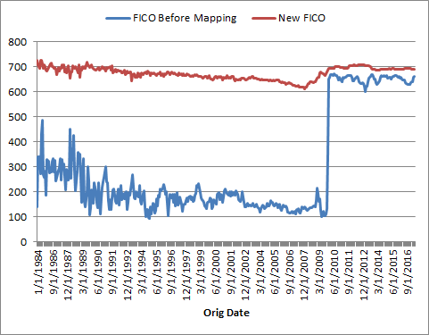
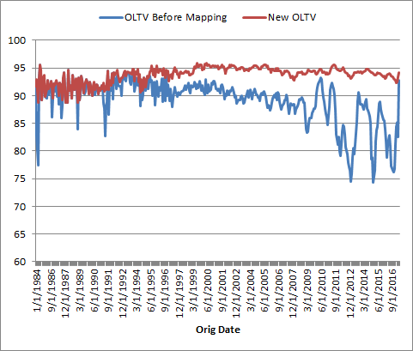

Loan Hist
- Add additional variables to scale.gnm_loan (see spreadsheet) in the same folder
  - loanAge
  - delMonths
  - removalReasonType
  - schamBalance
- Fill missing values for the following variables in scale.gnm_loanOrig:
  - loanAge
  - cltv
  - schamBalance
- Fill loanAge as follows:
There is dependency of laonAge and cltv. So we need to fill in all loan age numbers then recalculate factor for the cases with missing loanAge.
- The dependency is loanAge -> factor -> cltv
- Loan age is calculated by the difference between originationDate and asof
- The cases loanAge > 260 will be marked as 360
- Fill cltv as follows:
  - Calculate factor as:
1 - ((1 + origNoteRate / 1200)^loanAge - 1) / ((1 + origNoteRate / 1200)^360 - 1)
  - Calculate the HPA / HPA series:
Requires Extending the Time Series to the latest factor date using an assumption of 3% HPA
  - Fill cltv based on factor and HPA:
cltv = origLTV * factor / HPA
- Fill schamBalance as follows:
  - Use calcScham as primary source.
  - If null, use schamBalance.
  - If null, use currentBalance.

Loan Eligibility
Loan Incentive
Loan Burnout
Follow the algorithm of Conventional v2.41 ScaleDB.

Approximately 21% of original FICO values were missing in the table. The binning approach reduces this count to 6% and the remaining cases are handled through the nearest neighbor strategy.

